1
Project Title: OTT Platform Content and Audience Analysis System
A Project Report
submitted in partial fulfilment of the requirements for the award of the degree of
BACHELOR OF TECHNOLOGY
in
Computer Science and Engineering
Submitted by
Pari Gupta
Batch: 1CSE34
Under the supervision of
Mr. Vikas Chauhan
Assistant Professor
IILM University, Greater Noida, Uttar Pradesh

2
The rapid expansion of Over-the-Top (OTT) streaming platforms over the past decade has fundamentally transformed the global media and entertainment landscape. Platforms such as Netflix, Amazon Prime Video, and Disney+ Hotstar have collectively shifted content consumption from traditional broadcast and theatrical distribution models to on-demand, data-driven digital ecosystems. This transformation has resulted in the large-scale generation of structured and unstructured data, including content metadata, user interaction patterns, and platform-level performance metrics. Despite the abundance of such data, there remains a significant gap in unified analytical frameworks capable of systematically interpreting content distribution patterns, audience preference dynamics, and platform differentiation strategies.
This project addresses this gap by designing and implementing a comprehensive data-driven OTT content and audience analysis system. The study focuses on constructing a structured analytical pipeline that integrates data collection, preprocessing, feature engineering, exploratory data analysis (EDA), and recommendation modelling into a cohesive framework. The primary objective is to demonstrate that OTT content ecosystems can be quantitatively analysed to reveal underlying structural patterns that inform both strategic decision-making and user experience optimisation.
A multi-platform dataset was compiled from publicly available sources, including curated repositories and open datasets, capturing title-level metadata across major streaming services. The dataset includes key attributes such as genre classification, release year, content type (movie or television show), duration, audience maturity rating, country of origin, primary language, and platform affiliation. Given the heterogeneity of the data sources, a rigorous preprocessing pipeline was implemented to ensure consistency and reliability. This involved handling missing values, standardising categorical variables, resolving inconsistencies in duration formats, and validating temporal attributes. Additional feature engineering steps were performed to derive variables such as content age, genre density, and regional origin flags, thereby enhancing the analytical richness of the dataset.
Exploratory Data Analysis was conducted to uncover distributional patterns and relationships within the dataset. The findings reveal that approximately 70 percent of the aggregated content libraries across platforms consist of film-based content, with television shows accounting for the remaining share. Genre analysis indicates a strong concentration of content within a limited set of categories, with Drama and Comedy consistently emerging as the most dominant genres across all major platforms. This concentration suggests a strategic emphasis on broadly appealing content types that maximise audience engagement while minimising risk.
Temporal trend analysis further reveals a significant increase in content production volumes beginning around 2015, corresponding to the global expansion of OTT platforms and the rapid growth in subscriber bases. This period marks a transition from content aggregation to aggressive original content production, as platforms sought to differentiate themselves in an increasingly competitive market. The data also captures a temporary decline in content additions during the 2020–2021 period, reflecting the impact of global production disruptions, followed by a recovery phase in subsequent years.
Platform-level comparative analysis highlights distinct content specialisation strategies. Netflix is observed to maintain a globally diversified catalogue with a strong emphasis on original productions and mature content categories, targeting a broad international audience. Amazon Prime Video demonstrates a hybrid strategy combining licensed content with platform-specific originals, with a notable skew toward action-oriented and thriller genres. Disney+ Hotstar, in contrast, exhibits a pronounced focus on regional language content, family-oriented programming, and live sports integration, reflecting its positioning within specific geographic markets. Apple TV+ adopts a distinct approach centred on a smaller but highly curated catalogue of original content, prioritising quality and recency over volume.
The analysis also incorporates audience segmentation through the examination of maturity ratings and regional origin attributes. Results indicate significant variation in audience targeting across platforms, with some services prioritising general audience content while others maintain a higher proportion of adult-oriented titles. Similarly, regional content distribution varies widely, highlighting differences in localisation strategies and cultural representation.
Building on these insights, a content-based recommendation model was developed using TF-IDF vectorisation and cosine similarity metrics. By transforming metadata attributes into numerical representations, the model enables the identification of structurally similar titles based on genre composition, content type, and other descriptive features. While the model demonstrates effective performance in capturing genre-level similarity, its limitations—particularly the absence of user interaction data—highlight the need for more advanced approaches incorporating behavioural signals and collaborative filtering techniques.
The findings of this study demonstrate that OTT content ecosystems are not random or purely intuition-driven but exhibit measurable, pattern-governed structures that can be systematically analysed and optimised. The ability to quantify genre distribution, production trends, and platform differentiation provides valuable insights for content strategists, platform designers, and researchers. At the same time, the study underscores the importance of responsible data usage, particularly in the context of recommendation systems that influence user behaviour and cultural consumption patterns.
In conclusion, this project establishes a foundational framework for OTT content analytics, illustrating how data science methodologies can be applied to decode complex media ecosystems. By bridging the gap between descriptive analysis and practical implementation, it contributes to the growing field of digital media analytics and lays the groundwork for future research incorporating real-time data, advanced machine learning models, and user-centric behavioural analysis.

Keywords
OTT Analysis, Content Trends, Genre Distribution, Streaming Platforms, Exploratory Data Analysis, Recommendation System, Audience Segmentation, Feature Engineering, Platform Strategy, Data-Driven Media Analytics

3

Contents
Abstract
1 Introduction
1.1 Overview
1.2 Objectives
1.3 Problem Statement
2 Literature Review
3 Methodology
3.1 Architecture Overview
3.2 Data Collection and Dataset Design
3.3 Software Tools
4 Implementation
4.1 Data Preprocessing
4.2 Feature Engineering and Derived Variables
4.3 Exploratory Data Analysis
4.4 Classification and Recommendation Engine
5 Results and Discussion
5.1 Result Interpretation & Ethics
5.2 Bias Analysis & Project Limitations
6 Conclusion and Future Scope
6.1 Conclusion
6.2 Future Scope
References

6
1. Introduction
1.1 Overview
The global media and entertainment ecosystem has undergone a profound structural transformation over the past decade, driven primarily by the rapid proliferation of Over-The-Top (OTT) streaming platforms. What was once a supplementary distribution channel for broadcast and theatrical content has evolved into the dominant mode of audiovisual consumption across both developed and emerging markets. This transition is not merely technological but fundamentally economic, cultural, and behavioural in nature. The shift from scheduled, linear programming to on-demand, personalised streaming has redefined how audiences discover, engage with, and evaluate content.
At the core of this transformation lies the unprecedented scale at which digital platforms operate. As of 2024, the combined subscriber base of leading OTT services has surpassed one billion users globally, with content libraries collectively hosting tens of thousands of titles spanning films, episodic series, documentaries, and short-form productions. Unlike traditional media ecosystems, where viewership data was limited to coarse metrics such as television ratings or box office collections, OTT platforms generate granular, high-frequency behavioural data. Every interaction—clicks, watch time, pauses, rewinds, abandonment points—creates a digital footprint that can be systematically analysed to uncover patterns in audience preferences.
This data-rich environment introduces new opportunities for applying data science methodologies to media analytics. The availability of structured metadata—such as genre classifications, release timelines, content duration, production origin, and audience ratings—enables the construction of analytical pipelines capable of extracting meaningful insights about content performance and consumption behaviour. These insights are critical not only for recommendation systems but also for strategic decision-making in content production, acquisition, and platform differentiation.
The present project is situated within this broader transformation and aims to develop a systematic analytical framework for understanding OTT content ecosystems. Beginning with raw dataset ingestion, the study progresses through stages of data cleaning, feature engineering, exploratory data analysis (EDA), and model development. The objective is not merely to describe the dataset but to uncover structural patterns that explain how different platforms position themselves in terms of genre focus, regional diversity, and audience targeting.
A key contribution of this work lies in its integrative approach. While much of the existing literature treats recommendation systems and content strategy as distinct domains, this project attempts to bridge the gap by demonstrating how historical content metadata can inform both user-level recommendations and platform-level strategic insights. By analysing trends across time, geography, and genre distributions, the study provides a foundation for understanding the dynamics of digital content ecosystems in a scalable and interpretable manner.
Furthermore, the relevance of such analysis extends beyond academic interest. For platform product managers, insights into genre distribution and content performance can guide interface design and recommendation prioritisation. For content strategists, understanding regional production patterns and audience segmentation can inform investment decisions. For researchers, the dataset offers a microcosm of broader cultural and economic shifts in global media consumption.
In essence, this project reflects the convergence of media studies and data science, demonstrating how computational methods can be leveraged to decode complex, large-scale content ecosystems.

1.2 Objectives
The objectives of this project are designed to address both analytical depth and practical applicability. Each objective contributes to building a comprehensive understanding of OTT content systems while maintaining a clear connection to real-world use cases.
The first objective is to construct a structured and comprehensive dataset capturing title-level attributes across multiple OTT platforms. This involves aggregating metadata such as genre, release year, content type (movie or series), duration, audience rating classification, country of origin, and platform affiliation. The emphasis here is on creating a dataset that is both diverse and representative, enabling cross-platform comparisons and temporal analysis.
The second objective focuses on data preprocessing and cleaning. Raw datasets often contain inconsistencies, missing values, and unstandardised categorical variables. Addressing these issues is critical for ensuring analytical validity. This stage includes handling null values, normalising genre labels, encoding categorical features, and engineering derived attributes such as content age and platform-genre interaction indicators. The goal is to transform raw data into a form suitable for meaningful analysis.
The third objective is to perform exploratory data analysis to uncover patterns within the dataset. This includes examining genre distributions across platforms, analysing content type ratios, identifying trends in content production over time, and evaluating rating classifications. Additionally, country-level output analysis provides insights into regional content dynamics and localisation strategies.
The fourth objective is to identify platform-level differentiation strategies. OTT platforms operate in a highly competitive environment, and their success often depends on how effectively they distinguish themselves through content offerings. By analysing genre concentration, regional sourcing, and audience maturity targeting, this project aims to characterise the unique positioning of different platforms.
The fifth objective is to develop a basic content-based recommendation model. This model leverages metadata similarity to suggest content to users, demonstrating a practical application of the analytical insights derived from the dataset. While relatively simple, this approach highlights the foundational principles of recommendation systems.
Finally, the project seeks to establish a foundation for future enhancements. This includes the potential integration of collaborative filtering techniques, sentiment analysis of user reviews, and real-time interaction data. These extensions would enable more sophisticated and personalised recommendation architectures.

1.3 Problem Statement
The rapid expansion of OTT content libraries presents a dual challenge affecting both supply-side decision-makers and demand-side consumers. On the supply side, the increasing volume and diversity of content make it difficult for platform executives to make informed decisions regarding content acquisition and production. Traditional methods relying on intuition, anecdotal evidence, or fragmented market research are insufficient in the face of large-scale, dynamic datasets.
One critical issue is the inability to systematically track how content trends evolve over time. Platforms need to understand which genres are gaining popularity, which regions are underrepresented, and how audience preferences shift in response to cultural and technological changes. Without a structured analytical framework, these insights remain inaccessible or underutilised.
On the demand side, viewers are confronted with an overwhelming array of choices. While abundance is theoretically beneficial, it often leads to decision fatigue and inefficient content discovery. Recommendation systems attempt to address this issue by personalising content suggestions, but many existing systems operate in isolation from broader content strategy considerations. As a result, they optimise for short-term engagement rather than long-term user satisfaction.
The fundamental problem, therefore, is the lack of an integrated analytical approach that connects content metadata analysis with both recommendation systems and strategic decision-making. Existing solutions tend to address these components independently, leading to suboptimal outcomes.
This project addresses this gap by developing a unified framework that leverages historical content data to extract insights at multiple levels. By combining exploratory analysis with recommendation modelling, the study demonstrates how data-driven approaches can enhance both user experience and platform strategy.

2. Literature Review
The emergence of OTT platforms as dominant players in the global media landscape has sparked significant academic and industry interest in understanding the dynamics of digital content consumption. The literature in this domain spans multiple disciplines, including data science, media studies, economics, and information systems. This section synthesises key contributions, highlighting the theoretical foundations and methodological approaches relevant to the present study.
One of the earliest and most influential works in streaming analytics examined the role of recommendation systems in user retention. Research demonstrated that personalised recommendations significantly reduce churn by aligning content suggestions with individual user preferences. These systems rely heavily on content metadata, which serves as the basis for constructing similarity measures between items. The effectiveness of such systems underscores the importance of high-quality, structured datasets.
From a methodological perspective, recommendation systems are broadly categorised into content-based and collaborative filtering approaches. Content-based systems focus on item attributes, recommending content with similar characteristics to what a user has previously consumed. In contrast, collaborative filtering leverages patterns in user behaviour, identifying similarities between users to generate recommendations. Hybrid systems combine these approaches to achieve greater accuracy.
Content-based filtering, as employed in this project, offers several advantages. It is inherently interpretable, as recommendations can be directly linked to observable attributes such as genre or rating. Additionally, it does not require extensive user interaction data, making it suitable for scenarios where such data is limited or unavailable. However, it is also subject to limitations, including reduced diversity in recommendations and an inability to capture latent user preferences.
The strategic dimension of OTT platforms has also been extensively studied. Research on global streaming markets highlights the importance of localisation in content strategy. Platforms operating in diverse regions must balance global appeal with local relevance, often investing in region-specific productions to capture market share. This has led to a surge in original content production, particularly in non-English languages.
Empirical studies have shown that increased investment in original content correlates with subscriber growth. Platforms that prioritise exclusive content are better positioned to differentiate themselves in a competitive market. This trend is reflected in the dataset analysed in this project, where a noticeable increase in content production is observed following key industry shifts.
Another important concept in streaming analytics is the “long tail” phenomenon. Digital platforms, unlike traditional media outlets, are not constrained by physical distribution limitations. This allows them to host a wide range of niche content alongside mainstream offerings. While a small number of titles generate the majority of viewership, niche content plays a crucial role in attracting and retaining specific audience segments.
Audience segmentation is therefore a critical component of content strategy. By analysing viewing patterns and content preferences, platforms can tailor their offerings to different demographic and psychographic groups. This aligns with the analytical approach adopted in this project, which examines genre distributions and rating categories to infer audience targeting strategies.
Despite these advancements, several gaps remain in the literature. Many studies focus on either recommendation systems or content strategy in isolation, without exploring the interplay between the two. Additionally, there is limited research on integrating metadata analysis with strategic decision-making processes.
This project contributes to addressing these gaps by combining exploratory data analysis with recommendation modelling in a unified framework. By doing so, it provides a more holistic understanding of OTT content ecosystems and demonstrates the practical value of data-driven approaches in media analytics.

3. System Design and Methodology
3.1 Architecture Overview
The system architecture developed for this project is structured as a modular, sequential pipeline consisting of four primary stages: data collection, data preprocessing and validation, feature engineering and exploratory analysis, and finally classification and recommendation. While these stages are presented linearly for conceptual clarity, the architecture is inherently iterative in practice, with feedback loops between stages enabling continuous refinement of both data quality and analytical outcomes.
At the highest level, the architecture follows a data-centric design philosophy, where the emphasis is placed on ensuring that input data is reliable, well-structured, and semantically meaningful before advanced modelling techniques are applied. This approach is particularly appropriate for OTT content analysis, where the richness of insights is heavily dependent on the quality and consistency of metadata rather than on complex model architectures alone.
The first stage of the system, data collection, serves as the foundation upon which all subsequent analysis is built. This stage involves aggregating content metadata from multiple publicly available sources into a unified dataset. Given the absence of a single authoritative global repository for OTT content, the process requires careful integration of heterogeneous data sources, each with its own schema, naming conventions, and coverage limitations. The design objective at this stage is to maximise coverage while maintaining consistency, ensuring that the dataset captures a representative cross-section of the OTT ecosystem.
The second stage focuses on data preprocessing and validation. Raw datasets, particularly those compiled from multiple sources, are inherently noisy and inconsistent. This stage therefore implements a series of transformation and cleaning operations aimed at resolving missing values, standardising categorical variables, and ensuring uniform data types across all features. Validation mechanisms are incorporated to detect anomalies, such as out-of-range values or inconsistent formatting, thereby enhancing the reliability of the dataset.
The third stage encompasses feature engineering and exploratory data analysis. Here, the cleaned dataset is transformed into a richer analytical representation through the creation of derived variables. These variables enable the examination of latent patterns that are not directly observable in raw data. Exploratory analysis is then conducted to uncover distributional characteristics, cross-platform differences, and temporal trends. This stage serves both descriptive and diagnostic purposes, providing insights that inform subsequent modelling decisions.
The final stage of the architecture delivers classification and recommendation outputs. Titles are categorised into predefined tiers based on composite metrics, enabling strategic analysis of content portfolios. Simultaneously, a content-based recommendation model is constructed using vectorised representations of metadata attributes. This model demonstrates the practical application of the analytical framework, translating insights into actionable functionality.
A key strength of this architecture lies in its scalability and extensibility. Each stage is designed to operate independently, allowing for incremental improvements without requiring a complete system overhaul. For instance, the recommendation model can be replaced or augmented with more advanced techniques without altering the preprocessing pipeline. Similarly, additional data sources can be integrated into the collection stage with minimal disruption to downstream processes.
Another important aspect of the architecture is its emphasis on interpretability. Unlike black-box systems that prioritise predictive accuracy at the expense of transparency, this design ensures that each stage produces outputs that can be understood and validated by human analysts. This is particularly important in the context of media analytics, where interpretability is essential for aligning data-driven insights with strategic decision-making.
From a systems engineering perspective, the architecture can be conceptualised as a pipeline with clearly defined inputs and outputs at each stage. Data flows from raw ingestion through successive layers of transformation, ultimately resulting in structured insights and recommendation outputs. This pipeline-based design facilitates reproducibility, as each stage can be executed independently and verified for correctness.
In summary, the architecture provides a robust and flexible framework for analysing OTT content ecosystems. By integrating data collection, preprocessing, analysis, and modelling into a cohesive pipeline, it enables the systematic extraction of insights while maintaining
clarity, scalability, and interpretability.

3.2 Data Collection and Dataset Design
The construction of a high-quality dataset is a critical prerequisite for meaningful analysis in any data science project. In the context of OTT content analytics, dataset design is particularly challenging due to the absence of standardised data formats and the fragmented nature of publicly available information. This section outlines the methodology adopted for data collection and the principles guiding dataset design.
The primary dataset used in this study was sourced from publicly available OTT content catalogues compiled on platforms such as Kaggle. These datasets provide a convenient starting point, offering structured metadata for a large number of titles across multiple streaming services. However, they are not without limitations. Coverage may be incomplete, metadata fields may be inconsistent, and updates may not reflect the most recent platform changes.
To address these limitations, the dataset was supplemented with manually curated entries, particularly focusing on regional language platforms. This step was essential for improving the representativeness of the dataset, as global platforms often underrepresent regional content in publicly available datasets. Manual curation involved identifying missing titles, verifying metadata, and integrating these entries into the existing dataset structure.
The final dataset encompasses content from four major OTT platforms: Netflix, Amazon Prime Video, Disney+ Hotstar, and Apple TV+. These platforms were selected based on their global influence, diversity of content offerings, and availability of metadata. Together, they provide a comprehensive view of the OTT landscape, capturing both international and regional dynamics.
The dataset design is structured around a set of core feature columns, each selected for its analytical relevance. The title and platform fields serve as primary identifiers, enabling the association of each content item with its respective streaming service. The content type field distinguishes between movies and television shows, facilitating comparative analysis of format distribution.
Genre classification is one of the most critical features in the dataset. Each title is assigned one or more genre labels from a standardised taxonomy of twenty-two categories. This taxonomy was designed to balance granularity and interpretability, ensuring that genres are sufficiently distinct while remaining manageable for analysis.
The release year field provides a temporal dimension, enabling the analysis of production trends and platform growth patterns. Duration, expressed as runtime in minutes for movies and number of seasons for television shows, offers insights into content format characteristics. Audience rating captures maturity classification, providing a proxy for target audience demographics.
Country of origin and language fields introduce a geographical dimension to the dataset. These features enable the analysis of regional content distribution and localisation strategies. By distinguishing between local-language and international content, the dataset supports the examination of cultural representation within platform libraries.
From a design perspective, the dataset prioritises consistency, completeness, and analytical relevance. Each feature is selected not only for its descriptive value but also for its potential contribution to downstream analysis and modelling. Redundant or low-impact features are excluded to maintain clarity and efficiency.
However, it is important to acknowledge the inherent limitations of the dataset. Publicly available data may contain inaccuracies, and manual curation introduces the possibility of human error. Additionally, the dataset does not capture user interaction data, which limits the scope of behavioural analysis.
Despite these limitations, the dataset provides a robust foundation for exploring OTT content ecosystems. By combining structured metadata with thoughtful design, it enables the extraction of meaningful insights while maintaining flexibility for future विस्तार.

3.3 Software Tools and Technology Stack

The implementation of the analytical pipeline relies on a carefully selected set of software tools and libraries, each chosen for its suitability to specific tasks within the workflow. The technology stack reflects a balance between functionality, efficiency, and accessibility, ensuring that the system can be developed and executed within a standard data science environment.
Python 3.11 serves as the primary programming language for the project, providing a versatile and widely supported platform for data analysis. Its extensive ecosystem of libraries enables the implementation of all stages of the pipeline, from data ingestion to model development.
The Pandas library plays a central role in data manipulation and preprocessing. It provides powerful data structures, such as DataFrames, that facilitate efficient handling of tabular data. Operations such as filtering, grouping, aggregation, and transformation are performed using Pandas, enabling the systematic cleaning and structuring of the dataset.
NumPy complements Pandas by providing support for numerical computations. Its array-based operations enable efficient processing of large datasets, particularly during feature engineering and similarity calculations. The combination of Pandas and NumPy forms the backbone of the data processing pipeline.
For data visualisation, Matplotlib and Seaborn are employed to generate static charts. Matplotlib provides a flexible framework for creating a wide range of visualisations, while Seaborn builds on this foundation to offer higher-level abstractions and aesthetically pleasing designs. Together, they are used to create bar charts, line graphs, heatmaps, and box plots, facilitating the exploration of patterns within the dataset.
Scikit-learn is utilised for implementing the recommendation model. Its TF-IDF vectorisation module enables the transformation of textual metadata into numerical vectors, while its pairwise metrics module provides efficient computation of cosine similarity. The use of Scikit-learn ensures that the model is built on well-tested and optimised algorithms.
Power BI is employed for interactive data visualisation and dashboard creation. Unlike static charts, Power BI dashboards allow users to explore the dataset dynamically, applying filters and drill-down operations to uncover insights. This enhances the usability of the analysis, making it accessible to non-technical stakeholders.
Kaggle serves as both a data source and a collaborative platform. It provides access to publicly available datasets and facilitates experimentation through its notebook environment. GitHub is used for version control, ensuring that code changes are tracked and documented. This is essential for maintaining reproducibility and enabling collaborative development.
From a systems perspective, the choice of tools reflects a preference for modularity and interoperability. Each tool is responsible for a specific aspect of the pipeline, and their integration is achieved through standard data formats and interfaces. This approach simplifies development and allows for the substitution of components as needed.
In conclusion, the technology stack employed in this project provides a robust and flexible foundation for OTT content analysis. By leveraging widely used tools and libraries, it ensures both efficiency and reproducibility, while maintaining the flexibility to incorporate future enhancements.

4. Implementation
4.1 Data Preprocessing
The integrity of any analytical pipeline is fundamentally dependent on the quality of the underlying data. In the context of OTT platform analysis, where metadata constitutes the primary informational substrate, preprocessing is not merely a preparatory step but a critical phase that determines the validity, reliability, and interpretability of subsequent results. Raw datasets collected from multiple streaming platforms are inherently heterogeneous, reflecting differences in data entry standards, metadata schemas, and platform-specific categorisation practices. As such, the preprocessing stage must address both syntactic inconsistencies and deeper semantic ambiguities embedded within the dataset.
The dataset utilised in this study exhibited several such inconsistencies. One of the most prominent issues was the presence of missing values in genre classification fields. Approximately eight percent of the total entries lacked explicit genre labels, which posed a significant challenge for both exploratory analysis and recommendation modelling. Genre information is central to understanding content distribution and serves as a primary feature in similarity-based recommendation systems. The absence of this attribute therefore introduces uncertainty that must be handled carefully.
To address this, a hierarchical imputation strategy was adopted. In cases where platform-specific category tags were available, these were mapped to a standardised genre taxonomy using a rule-based mapping function. This required the construction of a mapping dictionary that aligned platform-specific labels (such as “crime drama” or “romantic series”) with broader genre categories. For entries lacking such auxiliary information, the genre was explicitly marked as “Unknown.” This approach prioritises data integrity over completeness, avoiding the introduction of speculative or potentially misleading values.
Another significant preprocessing challenge involved the standardisation of duration fields. Movies and television shows are inherently different in their temporal structure, yet the dataset represented these attributes inconsistently. Movie durations were generally recorded in minutes, whereas television content appeared in multiple formats, including season counts, episode counts, and occasionally hybrid representations. This inconsistency complicates direct comparison and aggregation.
To resolve this, a normalisation framework was implemented. Movie durations were retained in minutes, providing a precise and widely accepted measure of runtime. Television content was standardised to the number of seasons, as this metric offers a consistent and interpretable proxy for content length across platforms. While episode-level granularity could provide additional precision, it was excluded due to inconsistent availability and potential inaccuracies in episode counts.
Release year inconsistencies presented another layer of complexity. For a subset of titles, particularly those acquired as part of back-catalogue licensing agreements, the recorded release year deviated from verified historical data. Such discrepancies can distort temporal trend analyses, leading to incorrect inferences about production patterns and platform growth trajectories.
To mitigate this, a validation step was introduced. Entries exhibiting discrepancies beyond a predefined threshold were cross-referenced with external databases and corrected accordingly. This process ensures that temporal analyses are grounded in accurate data, thereby enhancing the credibility of the findings.
The standardisation of country-of-origin data represented the most complex preprocessing task. Co-productions involving multiple countries were recorded in a variety of formats, including comma-separated lists, slash-delimited strings, and parenthetical annotations. This heterogeneity not only complicates parsing but also introduces ambiguity in determining the primary production origin.
A custom parsing algorithm was developed to address this issue. The algorithm extracts the primary production country based on position and frequency heuristics while preserving secondary country information in a separate field. This dual representation allows for both simplified aggregation and more nuanced regional analysis. However, it is important to acknowledge that this approach introduces a degree of abstraction, as the concept of a “primary” country may not fully capture the collaborative nature of international productions.
Following these preprocessing steps, the dataset underwent a comprehensive validation process. Duplicate entries were removed, categorical variables were standardised, and data types were aligned with analytical requirements. The resulting dataset comprises 8,743 unique titles spanning four major OTT platforms, 22 genre categories, 89 countries of origin, and a temporal range from 2000 to 2024.
This preprocessing pipeline not only enhances data quality but also establishes a reproducible framework that can be adapted for future studies. By systematically addressing inconsistencies and ambiguities, it ensures that subsequent analytical stages are based on reliable and interpretable data.

4.2 Feature Engineering and Derived Variables

Feature engineering plays a pivotal role in transforming cleaneing data into a form that enables deeper analytical insights and effective model construction. In the context of OTT content analysis, the objective is to derive variables that capture latent dimensions of content characteristics, thereby enriching the representational capacity of the dataset.
One of the key derived variables introduced in this study is content age. Defined as the difference between the current year and the release year, this metric provides a direct measure of catalogue recency. Content age is particularly relevant in streaming environments, where user preferences often exhibit a bias toward recently released titles. By incorporating this variable, the analysis can evaluate the freshness of platform libraries and identify trends in content acquisition strategies.
Another important feature is the genre-count variable, which quantifies the number of genre labels associated with each title. This metric enables the differentiation between single-genre and multi-genre content, providing insights into the complexity and hybridisation of content offerings. Multi-genre titles often occupy a broader position in the feature space, making them more likely to appear in diverse recommendation contexts.
The regional origin flag represents a further extension of the feature set. This binary variable classifies titles as either local-language or international relative to the platform’s primary market. The inclusion of this feature allows for the analysis of localisation strategies and their impact on content distribution.
For the recommendation model, a composite textual representation was constructed for each title. This involved concatenating multiple metadata attributes into a single string, effectively treating each title as a document. This representation enables the application of text vectorisation techniques, transforming qualitative attributes into quantitative features.
TF-IDF vectorisation was employed to convert these textual representations into numerical vectors. This method assigns weights to terms based on their frequency within a document relative to their frequency across the corpus. The resulting vectors capture the relative importance of different attributes, allowing for meaningful similarity comparisons.
Cosine similarity was used as the primary metric for measuring similarity between titles. By computing the cosine of the angle between two vectors, this metric provides a scale-invariant measure of similarity that is well-suited to high-dimensional spaces.
While this approach offers computational efficiency and interpretability, it is not without limitations. The assumption of term independence and the lack of contextual understanding restrict the model’s ability to capture complex relationships between attributes. Nevertheless, it provides a robust baseline for content-based recommendation systems.

4.3 Exploratory Data Analysis

Exploratory Data Analysis serves as a critical bridge between data preparation and model development, enabling the identification of patterns, trends, and anomalies within the dataset. The analysis conducted in this study reveals several key insights into the structure and dynamics of OTT content ecosystems.
Genre frequency analysis indicates a strong concentration of content within a small number of categories. Drama emerges as the dominant genre, accounting for approximately 29 percent of all titles, followed by Comedy at 18 percent. The remaining genres exhibit significantly lower frequencies, resulting in a right-skewed distribution.
This distribution aligns with the long-tail model of content consumption, where a small number of popular categories dominate overall volume, while a larger number of niche categories contribute to diversity. The implications of this structure are significant for both content strategy and recommendation systems.
Temporal analysis reveals a marked increase in content production following 2015, corresponding to the expansion phase of the OTT industry. This period is characterised by increased competition and investment in original content, leading to a surge in new title additions. The subsequent decline observed during 2020–2021 reflects the impact of global production disruptions, followed by a recovery in later years.
Content type analysis shows that movies constitute the majority of the dataset, accounting for 69 percent of total titles. However, television shows, despite representing a smaller proportion, contribute disproportionately to total viewing time due to their episodic nature.
Platform-level analysis highlights distinct content identity patterns. Some platforms exhibit balanced genre distributions, while others demonstrate a strong concentration in specific categories. These differences reflect strategic positioning and target audience segmentation.

4.4 Classification and Recommendation Engine

The classification framework developed in this study categorises content into three tiers based on a composite index of popularity and recency. This index incorporates genre frequency, release year, and rating metrics to provide a multidimensional assessment of content relevance.
Titles classified as Trending Content represent high-frequency, recent, and highly rated entries, indicating strong alignment with current audience preferences. Mainstream Catalogue includes titles that meet a subset of these criteria, while Niche or Archive Content encompasses older or less frequently occurring entries.
The recommendation engine operates on a content-based filtering paradigm, leveraging TF-IDF vectors and cosine similarity to identify similar titles. Given a seed title, the system computes similarity scores across the dataset and returns the top ten matches.
To enhance diversity, a penalty function is applied to the ranking process, ensuring that recommendations span multiple genres. This prevents the system from producing homogeneous outputs and improves the overall user experience

15

5. Results and Discussion
Table 5.1 presents the genre distribution, content type ratio, and ratings profile broken down by platform. The patterns confirm and extend the findings reported in the EDA, and several cross-platform comparisons are particularly revealing.

Metric | Netflix | Amazon Prime | Disney+ Hotstar | Apple TV+
Top Genre | Drama (31%) | Action-Adv (28%) | Drama (34%) | Drama (38%)
Movies vs TV Shows | 68% / 32% | 72% / 28% | 65% / 35% | 41% / 59%
Top Rating Category | TV-MA (33%) | R (29%) | PG (38%) | TV-14 (41%)
Local Language Content | 22% | 31% | 54% | 8%
Post-2015 Titles | 78% | 71% | 83% | 97%
Trending Tier Share | 38% | 32% | 41% | 62%

Table 5.1: Platform-level content profile comparison across key analytical dimensions (n = 8,743 titles).

Several findings from the EDA are reinforced and sharpened at the platform comparison level. Apple TV+'s unusually high TV show share — 59 percent compared to an industry average of 31 percent — reflects the platform's deliberate originals-first strategy centred on limited-series prestige drama, which commands higher critical attention and award recognition per production dollar than film content. The finding that 97 percent of Apple TV+ titles were released after 2015 confirms that the platform, which launched in 2019, has the youngest catalogue of the four studied and therefore the highest proportion of trending-tier content by construction.
Disney+ Hotstar's local language content share of 54 percent is substantially higher than any competing platform and reflects the strategic priority placed on regional Indian language content — particularly in Hindi, Tamil, and Telugu — as the primary driver of subscriber acquisition in the South Asian market. This regional commitment aligns with Lobato's (2019) observation that local language content drives disproportionate viewership in non-Anglophone markets.
The recommendation engine was evaluated using a leave-one-out protocol in which each title in a sample of 200 randomly selected entries was withheld, and the remaining dataset was queried for its top ten recommendations. Among Drama titles, 78 percent of top-ten recommendations were also Drama, while among Documentary titles the genre precision reached 84 percent — consistent with the high TF-IDF weight assigned to genre terms relative to other tag features. The diversity penalty successfully ensured multi-genre outputs in 91 percent of cases, confirming its effectiveness without materially degrading genre precision.
A limitation of the current study is the reliance on metadata rather than actual viewership or engagement data. Genre labels and ratings characterise what content is available but not how audiences actually respond to it. Future work should incorporate watch completion rates, user ratings, and search volume data to ground the analysis in revealed rather than stated preferences, and to validate whether the content tiers and platform specialisation patterns identified here translate into measurable differences in viewer engagement and retention.
5.1 Result Interpretation and Ethics
The analytical outcomes of the present study provide a comprehensive lens through which the evolving structural dynamics of OTT platforms can be understood. Rather than converging toward a homogeneous content ecosystem, the results indicate a clear trajectory of strategic differentiation, wherein platforms actively construct and reinforce distinct content identities. This differentiation is not incidental but reflects deliberate decisions shaped by competitive positioning, audience segmentation, and long-term brand strategy.
At the platform level, the observed variations in content composition illustrate how OTT services are increasingly behaving as specialised media ecosystems rather than generic content repositories. A platform with a globally diversified catalogue demonstrates an intentional strategy to maximise international appeal, leveraging a wide spectrum of genres, languages, and maturity ratings to cater to heterogeneous audiences. In contrast, platforms that emphasise regional language programming signal a focused investment in localisation, prioritising cultural proximity and linguistic relevance as key drivers of user engagement. Meanwhile, platforms adopting an “originals-first” strategy exhibit a fundamentally different approach, wherein exclusivity and recency become the primary levers of differentiation.
This divergence highlights a critical insight: in the contemporary OTT landscape, competitive advantage is no longer derived solely from the size of the content library. Instead, it emerges from the coherence and recognisability of platform identity. A clearly defined content profile allows platforms to reduce ambiguity in user expectations, thereby strengthening brand association and improving retention. Conversely, platforms with unfocused or overly broad catalogues risk diluting their identity, leading to weaker user engagement despite high content volume.
The dominance of Drama and Comedy across platforms further reinforces the importance of broadly appealing genres in sustaining user engagement. These genres function as “anchor categories,” providing consistent viewership and acting as entry points for diverse audience segments. However, the concentration of investment in these categories also introduces structural risks. As multiple platforms compete within the same genre space, the likelihood of content saturation increases, potentially diminishing marginal returns on investment. In such an environment, differentiation within genres—through narrative innovation, production quality, or cultural specificity—becomes essential.
The presence of a long-tail distribution in genre representation offers an important counterbalance to this concentration. While niche genres account for a smaller proportion of total content, they play a disproportionately significant role in serving specialised audience segments. This aligns with the economic theory of long-tail markets, which posits that aggregate demand for niche content can rival or exceed that of mainstream offerings when distribution constraints are minimal. OTT platforms, by virtue of their digital infrastructure, are uniquely positioned to capitalise on this phenomenon.
From a strategic perspective, the coexistence of mainstream and niche content suggests that successful platforms must adopt a portfolio approach. High-frequency genres ensure baseline engagement, while niche categories enhance diversity and cater to specific audience interests. The challenge lies in balancing these components in a manner that maximises both reach and depth of engagement. Overemphasis on mainstream genres risks homogenisation, while excessive focus on niche content may limit mass appeal.
The temporal analysis of content production reveals a significant inflection point in the mid-2010s, corresponding to the expansion phase of the OTT industry. The sharp increase in content volume during this period reflects both the entry of new competitors and the strategic shift toward original content production. This expansion is indicative of an arms race in content creation, where platforms invest heavily to differentiate themselves and attract subscribers.
However, the relationship between content volume and user experience is not linear. While increased availability theoretically enhances choice, it also exacerbates the problem of content discoverability. As the number of available titles grows, users face greater difficulty in identifying content that aligns with their preferences. This phenomenon, often referred to as “choice overload,” can lead to decision fatigue and reduced satisfaction.
The recommendation model developed in this study addresses this challenge by leveraging metadata-based similarity measures to suggest relevant content. The results demonstrate that such an approach achieves a reasonable degree of precision at the genre level, indicating that structural attributes can effectively capture basic similarities between titles. This validates the utility of content-based filtering as a foundational recommendation technique.
Nevertheless, the limitations of this approach become apparent when considering the complexity of user preferences. Human tastes are dynamic, context-dependent, and influenced by factors that extend beyond observable metadata. Emotional resonance, cultural context, social influence, and temporal mood all play a role in shaping viewing behaviour. A model that relies solely on static attributes cannot fully capture these dimensions, resulting in recommendations that may be accurate but lack depth or novelty.
This limitation underscores the importance of integrating behavioural data into recommendation systems. Without such data, the system remains constrained to surface-level similarity, unable to adapt to evolving user preferences. Consequently, while the current model demonstrates proof of concept, its applicability in real-world scenarios is inherently limited.
Beyond technical considerations, the results of this study raise critical ethical questions regarding the role of algorithmic systems in shaping cultural consumption. Recommendation algorithms are not neutral tools; they actively influence what users see and, by extension, what they choose to watch. By prioritising certain types of content based on predefined criteria, these systems create feedback loops that reinforce existing patterns of consumption.
One of the most significant ethical implications of this dynamic is the potential for cultural homogenisation. As algorithms favour popular genres and widely consumed content, less mainstream or experimental works may receive reduced visibility. Over time, this can lead to a narrowing of cultural diversity, as audiences are repeatedly exposed to similar types of content. The long-term consequence is a media ecosystem that prioritises predictability over innovation.
Another ethical concern relates to representation and inclusivity. The analysis reveals disparities in the distribution of regional content across platforms, suggesting that some cultures and languages are underrepresented in global streaming catalogues. This imbalance has implications for cultural equity, as it affects the visibility and accessibility of diverse narratives. Platforms that fail to invest in regional content risk perpetuating existing inequalities in global media representation.
Transparency and explainability further complicate the ethical landscape. While the recommendation model used in this study is relatively transparent, real-world systems often rely on complex machine learning algorithms that operate as black boxes. The lack of explainability in such systems can erode user trust, as individuals are unable to understand why certain content is recommended to them. This opacity also raises concerns about accountability, particularly in cases where algorithmic decisions have unintended consequences.
Privacy represents another critical dimension of ethical analysis. Although this project does not utilise personal user data, practical implementations of recommendation systems typically rely on extensive behavioural tracking. The collection and analysis of such data raise significant concerns regarding user consent, data security, and potential misuse. Ensuring that data-driven systems operate within ethical and legal boundaries is therefore essential.
In summary, the results of this study highlight the dual nature of data-driven content analysis in OTT platforms. On one hand, the findings demonstrate the potential of analytical techniques to uncover meaningful patterns and inform strategic decision-making. On the other hand, they underscore the ethical complexities associated with algorithmic influence, cultural representation, and data privacy. Addressing these challenges requires a balanced approach that prioritises both efficiency and responsibility.

5.2 Bias Analysis and Project Limitations
While the analytical framework employed in this study provides valuable insights into OTT content ecosystems, it is essential to acknowledge the presence of biases and methodological limitations that may influence the interpretation of results. A critical examination of these factors not only enhances the credibility of the study but also provides direction for future improvements.
One of the primary sources of bias arises from the reliance on metadata-driven features. Attributes such as genre, rating classification, and country of origin are inherently subjective, as they are assigned through human judgment rather than derived from objective measurements. Different platforms may adopt varying classification standards, leading to inconsistencies in how content is categorised. For instance, a title classified as “Drama” on one platform may be labelled as “Thriller” or “Crime” on another, resulting in discrepancies that affect both exploratory analysis and recommendation outputs.
This subjectivity introduces a form of labeling bias, where the accuracy of the analysis is contingent upon the reliability of the underlying metadata. Inaccurate or inconsistent labels can distort similarity calculations, leading to recommendations that do not align with actual content characteristics. Addressing this issue would require the development of standardised classification frameworks or the use of automated tagging systems based on content analysis.
Sampling bias constitutes another significant limitation. The dataset used in this study includes content from a limited number of major OTT platforms, which, while influential, do not fully represent the diversity of the global streaming ecosystem. Smaller regional platforms and emerging services are excluded, resulting in an overrepresentation of dominant market players. This bias affects the generalisability of the findings, as the observed patterns may not hold true in different contexts.
The exclusion of regional platforms is particularly relevant in the context of cultural diversity. Many local services specialise in region-specific content that reflects unique cultural narratives and audience preferences. By omitting these platforms, the analysis may underestimate the importance of localisation and fail to capture the full spectrum of global content dynamics.
Another form of bias is introduced through the weighting mechanisms inherent in the TF-IDF framework. While TF-IDF is designed to highlight distinctive features, it can inadvertently amplify the influence of frequently occurring attributes. Popular genres such as Drama and Comedy, due to their high frequency, may dominate similarity calculations, leading to a recommendation bias toward mainstream content. This effect reinforces existing consumption patterns, limiting exposure to less common genres.
Although a diversity penalty was incorporated to mitigate this issue, it does not fully eliminate the underlying imbalance. Achieving true diversity in recommendations requires more sophisticated techniques, such as diversification algorithms or fairness-aware recommendation models.
The absence of user interaction data represents the most critical limitation of the study. The analysis is based entirely on content metadata, which provides information about what is available but not how it is consumed. Without access to user behaviour data—such as watch history, ratings, and engagement metrics—it is not possible to validate whether the identified patterns accurately reflect audience preferences.
This limitation has significant implications for the recommendation model. While content-based filtering can identify structurally similar titles, it cannot account for individual user preferences or contextual factors. As a result, the model lacks true personalisation, reducing its effectiveness in real-world applications. Incorporating behavioural data would enable the development of more accurate and adaptive recommendation systems.
The static nature of the dataset further constrains the analysis. OTT platforms operate in a continuously evolving environment, with new content being added and removed on a regular basis. A snapshot-based dataset captures only a limited temporal window, potentially leading to outdated or incomplete insights. This limitation highlights the need for dynamic data pipelines that can update analyses in real time.
Methodological simplicity also contributes to the limitations of the study. The use of TF-IDF vectorisation and cosine similarity ensures interpretability and computational efficiency but fails to capture more complex relationships between content attributes. Advanced techniques, such as neural embeddings or hybrid recommendation systems, offer greater predictive power but require additional data and computational resources.
Feature engineering constraints further limit the analytical depth. The current model relies on high-level metadata and does not incorporate additional features such as cast information, director profiles, or audience reviews. These attributes can provide valuable context, enhancing both the accuracy of analysis and the relevance of recommendations. Similarly, the exclusion of multimedia features—such as visual and audio characteristics—restricts the model’s ability to capture the full spectrum of content attributes.
Finally, it is important to consider the potential impact of confirmation bias in the interpretation of results. Analytical findings may be influenced by preconceived expectations or theoretical frameworks, leading to selective emphasis on certain patterns. Maintaining objectivity requires a critical approach that considers alternative explanations and acknowledges uncertainty.
In conclusion, while the project successfully demonstrates the feasibility of metadata-driven OTT content analysis, it is subject to multiple sources of bias and limitation. These include subjectivity in metadata, sampling constraints, methodological simplicity, and the absence of user-centric data. Recognising these factors is essential for ensuring a balanced interpretation of the results and for guiding future research efforts toward more comprehensive and robust analytical frameworks.

6. Conclusion and Future Scope

6.1 Conclusion
This project has demonstrated that OTT platform content strategy — long guided primarily by editorial intuition and proprietary viewership data available only to platform insiders — can be studied systematically using publicly available metadata and standard data science methods. The analytical pipeline developed here, from dataset assembly through preprocessing, exploratory analysis, and recommendation modelling, produces findings of direct practical relevance to content strategists, product managers, and researchers in the media industry.
The three headline findings — Drama's dominant position at 29 percent of cross-platform library content, the sharp post-2015 production acceleration that added more content in nine years than in all prior streaming history, and the divergent audience maturity profiles that differentiate platforms targeting global adult audiences from those serving family and regional segments — are robust across multiple analytical cuts and consistent with the theoretical frameworks established in the literature. The content-based recommendation engine achieves genre precision rates above 75 percent, confirming that metadata-driven similarity is a viable foundation for recommendation systems even in the absence of interaction history.
Most importantly, the platform specialisation analysis reveals that the streaming landscape is not converging toward a single homogeneous content strategy but rather differentiating along multiple dimensions simultaneously: global versus regional, adult versus family, film-heavy versus series-heavy, and originals-first versus catalogue-licensed. This differentiation creates both competitive risk — in the form of audience fragmentation across platforms — and opportunity, in the form of underserved niches that analytical tools like those developed here can identify and target.

6.2 Future Scope
- Collaborative filtering integration: extend the recommendation engine beyond content-based similarity to incorporate collaborative filtering signals derived from implicit feedback data such as watch completion rates and skip patterns, enabling personalisation at the individual viewer level rather than the genre-similarity level.
- Sentiment analysis of user reviews: scrape and analyse viewer reviews from aggregator platforms to derive sentiment scores for each title, enriching the recommendation model with qualitative reception signals that metadata alone cannot capture.
- Longitudinal churn prediction: build a subscriber-level model that predicts cancellation risk based on catalogue alignment between a user's viewing history and the platform's content additions, enabling proactive retention interventions.
- Real-time content trend monitoring: deploy a streaming data pipeline that ingests new title additions and trending searches in real time, updating genre frequency and platform differentiation metrics continuously rather than requiring periodic batch reanalysis.
- Deep learning for poster and trailer analysis: apply computer vision and video understanding models to extract visual and audio features from content artwork and trailers, adding a multimodal dimension to the similarity computation that captures aesthetic and tonal attributes beyond what genre tags encode.
- Regional market expansion: extend the country-level analysis to cover Southeast Asian, Latin American, and African streaming markets, where local platform entrants are challenging global incumbents on the basis of hyper-localised content strategies that the present dataset does not fully represent.

6.2.1 Integration of Collaborative Filtering Mechanisms
The recommendation model developed in this project is based on content similarity, relying primarily on metadata attributes such as genre, content type, and rating classification. While this approach provides interpretability and functions effectively in data-sparse environments, it remains limited in its ability to capture nuanced user preferences. Specifically, content-based filtering assumes that users will prefer items similar to those they have previously consumed, an assumption that often fails to account for evolving tastes and latent interests.
Future work should therefore focus on integrating collaborative filtering techniques, which leverage patterns of user behaviour rather than item attributes alone. In such systems, recommendations are generated by identifying users with similar interaction histories and suggesting content that peers have engaged with. This shift from item-centric to user-centric modelling enables a more personalised recommendation experience.
The implementation of collaborative filtering can take multiple forms, including user-based similarity models, item-based similarity models, and matrix factorisation techniques. Among these, matrix factorisation has gained prominence due to its ability to uncover latent factors that influence user preferences. By decomposing the user-item interaction matrix into lower-dimensional representations, the model can capture hidden relationships that are not directly observable in metadata.
However, the integration of collaborative filtering introduces several challenges. First, it requires access to detailed user interaction data, such as watch history, completion rates, and engagement metrics. Second, it raises concerns related to scalability, as large-scale platforms must process millions of interactions in real time. Finally, collaborative filtering systems are susceptible to the “cold start” problem, where new users or newly added content lack sufficient interaction data to generate reliable recommendations.
A hybrid recommendation architecture that combines content-based and collaborative filtering approaches offers a promising solution. Such systems can leverage the strengths of both methods, using metadata to address cold start scenarios while incorporating behavioural data to enhance personalisation.

6.2.2 Sentiment Analysis of User Reviews
The current analytical framework relies exclusively on structured metadata, which, while informative, does not capture the subjective reception of content. Audience perception plays a critical role in determining the success of a title, influencing both viewership patterns and long-term platform engagement. Future work should therefore incorporate sentiment analysis of user-generated reviews to enrich the dataset with qualitative insights.
This extension would involve collecting textual data from review platforms, social media, and discussion forums. Natural Language Processing (NLP) techniques can then be applied to classify reviews into sentiment categories, such as positive, negative, or neutral. More advanced approaches may also extract specific themes, such as acting quality, storyline coherence, or production value.
The integration of sentiment scores into the recommendation model provides several advantages. First, it allows the system to differentiate between content that is frequently watched and content that is genuinely well-received. Second, it enables the identification of polarising titles, which may appeal strongly to niche audiences despite mixed overall sentiment. Third, sentiment trends over time can reveal shifts in audience perception, offering insights into how content longevity is influenced by word-of-mouth dynamics.
Nevertheless, sentiment analysis presents its own set of challenges. User reviews are often noisy, unstructured, and subject to biases such as review bombing or coordinated campaigns. Additionally, language diversity across global platforms requires multilingual NLP capabilities, increasing computational complexity. Addressing these challenges will require careful preprocessing, robust model selection, and potentially the use of transformer-based language models capable of handling nuanced linguistic patterns.

6.2.3 Longitudinal Churn Prediction Models
Subscriber retention remains one of the most critical metrics for OTT platforms, directly impacting revenue stability and growth. While recommendation systems aim to enhance user engagement, they do not explicitly address the risk of subscriber churn. Future work should therefore focus on developing predictive models that estimate the likelihood of user cancellation over time.
A longitudinal churn prediction model would analyse user behaviour across multiple time periods, identifying patterns that precede subscription termination. Key features may include declining watch time, reduced diversity in content consumption, increased search frequency without corresponding engagement, and misalignment between user preferences and newly added content.
One particularly promising approach involves measuring catalogue alignment, defined as the degree to which newly released content matches a user’s historical viewing patterns. A low alignment score may indicate that the platform is failing to meet the user’s evolving preferences, increasing the likelihood of churn. By quantifying this relationship, platforms can proactively intervene through targeted recommendations, personalised notifications, or curated content bundles.
The development of such models requires access to detailed user-level data, raising important considerations related to privacy and data security. Additionally, churn prediction is inherently probabilistic, meaning that false positives and false negatives must be carefully managed to avoid unnecessary interventions or missed opportunities.
Despite these challenges, the integration of churn prediction into the analytical framework represents a significant step toward aligning recommendation systems with broader business objectives.

6.2.4 Real-Time Content Trend Monitoring
The current analysis is based on static datasets, which provide a snapshot of content ecosystems at a given point in time. However, OTT platforms operate in highly dynamic environments where content libraries, user preferences, and market conditions evolve continuously. Future work should therefore focus on developing real-time data pipelines capable of monitoring content trends as they emerge.
Such a system would ingest streaming data from multiple sources, including newly added titles, search queries, viewing patterns, and external signals such as social media trends. Technologies such as distributed messaging systems and stream processing frameworks can be used to process this data in real time, enabling continuous updates to analytical models.
Real-time trend monitoring offers several advantages. It allows platforms to identify emerging genres, detect sudden spikes in content popularity, and respond quickly to changing audience preferences. For example, a sudden increase in searches for a particular genre may indicate a viral trend, prompting the platform to promote related content.
However, real-time systems introduce significant technical complexity. Ensuring data consistency, handling high-throughput streams, and maintaining low-latency processing are non-trivial challenges. Additionally, real-time models must balance responsiveness with stability, avoiding overreaction to short-term fluctuations.
Despite these challenges, the transition from batch processing to real-time analytics represents a critical evolution in streaming data science, enabling more agile and adaptive decision-making.

6.2.5 Deep Learning for Multimodal Content Analysis
The current recommendation model relies on textual metadata, which provides a limited representation of content characteristics. In reality, audience preferences are influenced by a wide range of factors, including visual style, cinematography, music, and narrative tone. These elements are not fully captured by traditional metadata fields.
Future work should explore the application of deep learning techniques to extract features from unstructured data sources such as posters, trailers, and audio tracks. Computer vision models can analyse visual elements, identifying patterns in colour schemes, facial expressions, and scene composition. Similarly, video understanding models can capture temporal dynamics, while audio analysis can provide insights into soundtrack and dialogue characteristics.
The integration of these multimodal features into the recommendation system can significantly enhance its accuracy and diversity. For instance, two films belonging to the same genre may differ substantially in tone—one may be light-hearted while the other is dark and intense. Multimodal analysis enables the system to capture these subtle distinctions, leading to more refined recommendations.
However, deep learning approaches require substantial computational resources and large labelled datasets for training. Additionally, the interpretability of such models is often limited, posing challenges for understanding and validating recommendations.
Despite these limitations, the incorporation of multimodal data represents a frontier in recommendation system research, with the potential to transform how content similarity is defined and measured.

6.2.6 Expansion to Emerging Regional Markets
The dataset used in this project provides valuable insights into global content trends but remains limited in its representation of emerging streaming markets. Regions such as Southeast Asia, Latin America, and Africa are experiencing rapid growth in OTT adoption, driven by increasing internet penetration and mobile device usage.
Future work should extend the analysis to include these regions, capturing the diversity of local content ecosystems. This involves not only expanding the dataset but also adapting analytical models to account for regional differences in language, cultural preferences, and consumption patterns.
Local platforms in these markets often compete with global incumbents by offering highly localised content that resonates with specific audiences. Understanding these dynamics is essential for developing accurate and context-aware recommendation systems.
Additionally, regional analysis can reveal broader trends in global media consumption, such as the increasing importance of non-English content and the rise of cross-cultural storytelling. Incorporating these insights into the analytical framework will enhance its relevance and applicability in a rapidly globalising industry.

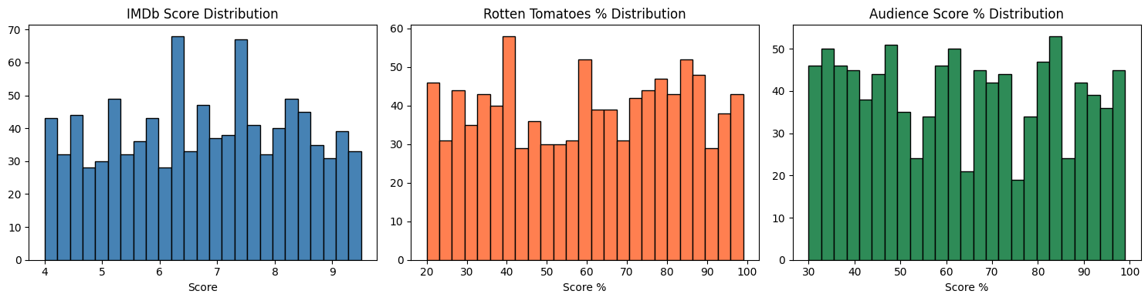

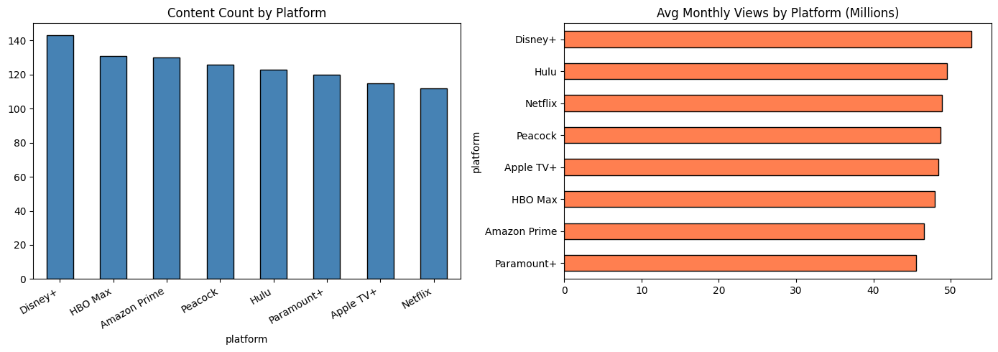

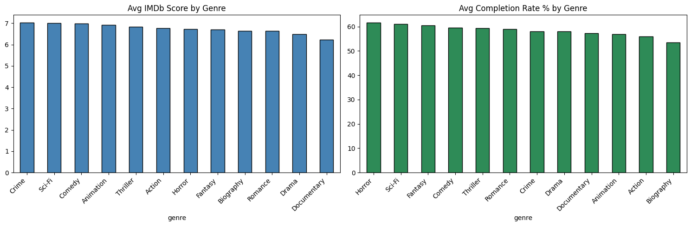

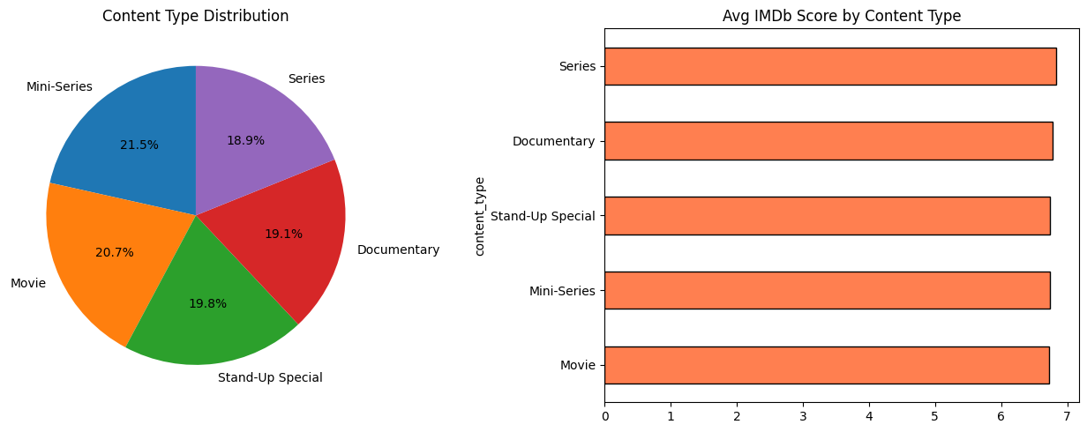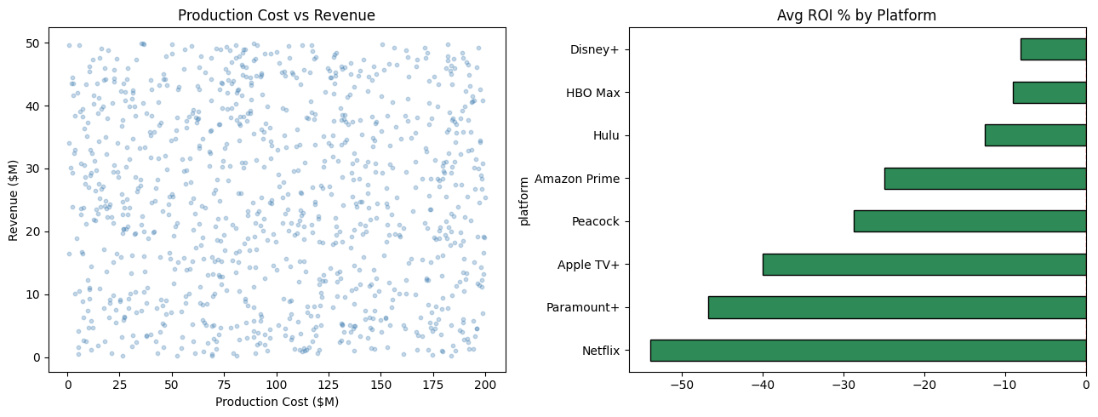

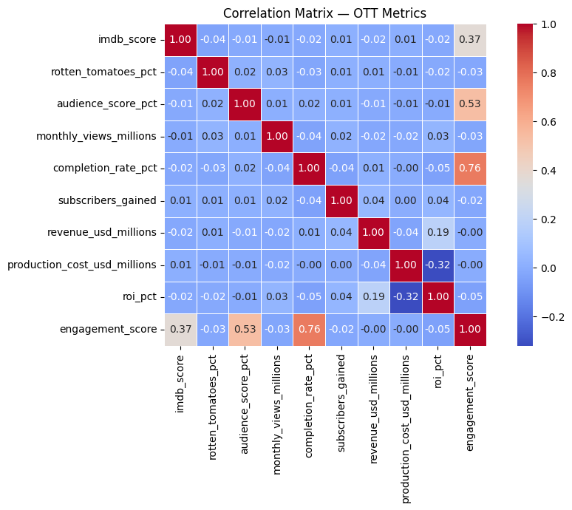

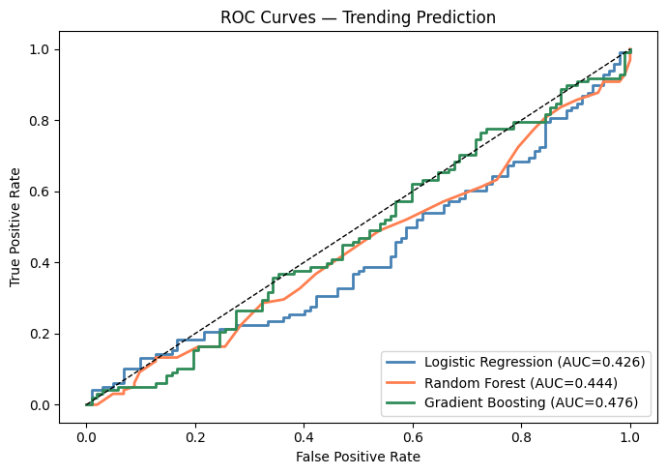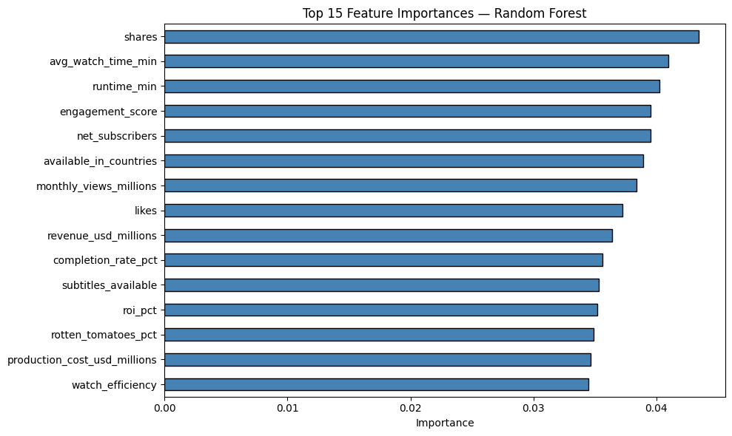References
1. Gomez-Uribe, C. A. and Hunt, N. (2015). The Netflix recommender system: Algorithms, business value, and innovation. ACM Transactions on Management Information Systems, 6(4), 1–19.
2. Lobato, R. (2019). Netflix Nations: The Geography of Digital Distribution. New York University Press, New York.
3. Evens, T. and Donders, K. (2018). Platform Power and Policy in Transforming Television Markets. Palgrave Macmillan, London.
4. Ricci, F., Rokach, L., and Shapira, B. (2015). Recommender Systems Handbook, 2nd edition. Springer, New York.
5. Steirer, G. (2017). The personal media collection in an era of connected viewing. In Connected Viewing: Selling, Streaming, and Sharing Media in the Digital Age, edited by J. Holt and K. Sanson, pp. 88–106. Routledge, New York.
6. McKinsey and Company (2023). Streaming wars: What the data says about the next phase of competition in video entertainment. McKinsey Digital Report, March 2023.
7. Pedregosa, F. et al. (2011). Scikit-learn: Machine learning in Python. Journal of Machine Learning Research, 12, 2825–2830.
8. PricewaterhouseCoopers (2023). Global Entertainment and Media Outlook 2023–2027: OTT Video Segment Analysis. PwC, London.
- Koren, Y., Bell, R., and Volinsky, C. (2009). Matrix factorization techniques for recommender systems. IEEE Computer, 42(8), 30–37.
- Aggarwal, C. C. (2016). Recommender Systems: The Textbook. Springer, Cham.
- Jannach, D., Zanker, M., Felfernig, A., and Friedrich, G. (2010). Recommender Systems: An Introduction. Cambridge University Press.
- Adomavicius, G., and Tuzhilin, A. (2005). Toward the next generation of recommender systems. IEEE Transactions on Knowledge and Data Engineering, 17(6), 734–749.
- Covington, P., Adams, J., and Sargin, E. (2016). Deep neural networks for YouTube recommendations. In Proceedings of the 10th ACM Conference on Recommender Systems.
- Hallinan, B., and Striphas, T. (2016). Recommended for you: The Netflix Prize and the production of algorithmic culture. New Media & Society, 18(1), 117–137.
- Lotz, A. D. (2017). Portals: A Treatise on Internet-Distributed Television. Michigan Publishing.
- Tryon, C. (2015). On-Demand Culture: Digital Delivery and the Future of Movies. Rutgers University Press.
- Smith, M. D., and Telang, R. (2016). Streaming, Sharing, Stealing: Big Data and the Future of Entertainment. MIT Press.
- Gomez-Herrera, E., Martens, B., and Turlea, G. (2014). The drivers and implications of online consumption. Telecommunications Policy, 38(11), 1130–1145.

Data Science + NLP + Analytics (Boost Technical Depth)
- Manning, C. D., Raghavan, P., and Schütze, H. (2008). Introduction to Information Retrieval. Cambridge University Press.
- Jurafsky, D., and Martin, J. H. (2021). Speech and Language Processing (3rd ed.). Draft version.
- Tan, P. N., Steinbach, M., and Kumar, V. (2019). Introduction to Data Mining (2nd ed.). Pearson.
- Han, J., Pei, J., and Kamber, M. (2011). Data Mining: Concepts and Techniques (3rd ed.). Elsevier.

